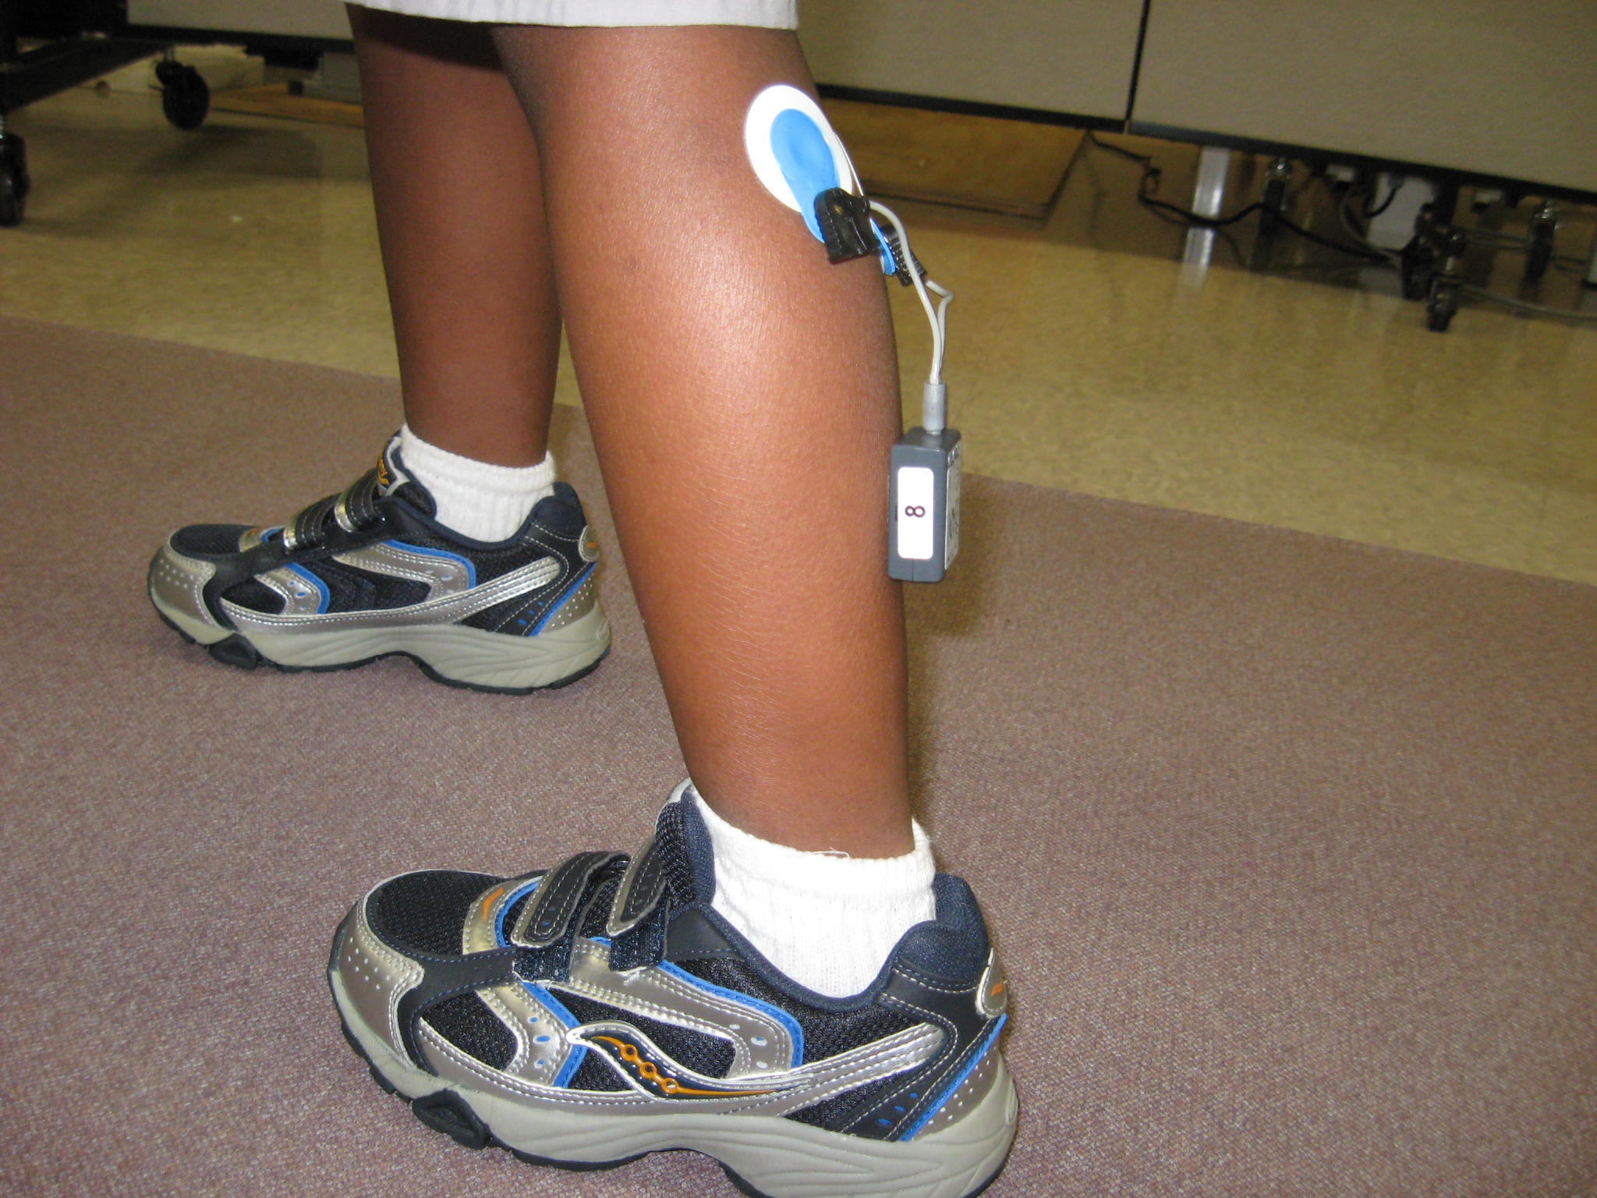

“A shoe grant from StrideRite.com provided footwear which is utilized in the biomechanics lab for studies involving the lower extremity. The shoes provide a standard footwear for subjects to wear while being tested. Projects currently in progress in the biomechanics lab include: comparison of ankle foot orthoses on emg and foot pressure; rocker bottom shoes and emg activity; comparison of exercise devices on emg and foot pressure and Physical Cost Index(PCI) and lower extremity immobilization.”

